**Always use Stock images and diagrams to illustrate**

# Introduction(peter):

Problem space; (address the dilemma from both technical & design perspectives)

Idea; (what it is)

There are a lot of club in UQ campus, but some UQ students who have joined club find it is hard to keep connected to the latest news and make friends with other members.In addition, it requires great efforts and much time for UQ club and society committee members to recruit new members and promote an event. So, we want to create an application that strengthen the connection between members and club organizers and Organizational work efficiency.

## Preliminary research

### Interviews:

We first conducted interviews within our team to get a better understanding of students’ pain points in their social lives at UQ. Nan, Peter and Alvin were the interviewers and Tony and Danson were the interviewees. (Note: When we were conducting the interviews, we just chose the “active community” as our topic, but had no idea about what to design or build.)

Tony is currently a member of UQ Boxing Club. Based on the interview, we found:

1. Even though Tony joined the club and attended regular boxing classes, he felt lacking communication with other participants, most of whom were UQ students.
2. Tony knew the Boxing club regularly held other events, such as welcome BBQ, but he did not attend it. Because he had no idea about whether it was past or when it would be held.
3. The main approaches that Tony got news from the club were Facebook and regular classes.
4. Tony would continue to be a member of Boxing Club, because he thought he could build his body and learn boxing skills.
5. In a boxing class, members were paired. But Tony did not make friends with his partners, potentially because he could not exchange contact details in the class.
6. He made friends with other members (not his partners) and maintained relationships in WeChat (a popular instant messaging app in China).

Danson has two roles. First we interviewed Danson as a potential member of UQ Beer Club. He was interested in the activities (we call them *events* in the rest of the proposal) that the club held, but he did not join it. We found:

1. He was interested in the events because he loved beer. He knew there was a Beer Club at UQ, but did not participate in any of the events it held.
2. He had no friends to go together with him.
3. Most of the club members were local students, as he observed. So he was afraid of language barriers and cultural differences.

And then, we continued to interview Danson as a committee member (we call him an *organiser* in the rest of the proposal) of UQ Chinese Student and Scholar Association. He worked for the society as an HR, and based on his experience, we found:

1. His main job was to recruit new committee members for the society.
2. He found it hard to keep a balance between study and society jobs.
3. He needed some motivation because he repeated to do similar tasks.
4. One of his task was to inform candidates of the time and place to be interviewed. A typical process how a candidate was informed is illustrated below:

<insert image here>

Based on what we learned from the interviews, we learned more about different types of clubs and identified three main categories of users. They are potential members, members, and organisers. And we found two fields of problems, that is, members’ social connections with clubs and with one another. We

### Questionnaire:

Later on, we designed and distributed an online questionnaire and collected 64 responses in two days. The main findings from the questionnaire are listed below and sorted by the role of participants:

For potential members:

1. 42% respondents have never joined a club.
2. 18% of the potential members are not interested in clubs.
3. They expect an active social club that matches their interests and have some free events.
4. Activities they like at UQ are: (1) freebies (2) Market Day (3) study (4) sports.

For existing members:

1. 93.5% of them get information about clubs on the Market Day.
2. They rate the activeness of the club they join as average.
3. 25% of existing members have never participated in any event.
4. Main motivations of joining a club are making friends and personal interests.
5. 61% of them get latest news from clubs via social media, such as Facebook.
6. They care about the time, place of the event, whether it is free, whether it is interesting, whether their friends attend, the outcomes, and communication.
7. It is hard for them to make decisions to participate.
8. Some of them find disconnected from the club.

For organisers (who are also existing members):

1. They rate the activeness of the club as high.
2. All of them use Facebook to inform members of news.
3. They hold events at least once per month.
4. They have trouble in organising information, promoting events, collaboration, being motivated and supported.
5. Their attitudes towards a new mobile social app vary.

## How can we use Social/Mobile theories; (and our academic research) to improve it?

Club is an organization combined by two or more people who have common interest and goal. A club have different styles and purposes such as hobbies and sports, social activities clubs, political and religious clubs, and so on. People take part in clubs for different purpose, but indeed, the clubs has occupied an important position in people’s leisure time. A survey reflects that more than 11.1 million people(60%) in Australia had participated in sport and physical recreation in 2013-2014. It is also claimed by Australian Bureau of Statistics that involvement in organised sports and physical activity generally decreased with age(Statistics, 2015). People aged 15-24 years had the highest rate of involvement (44%). Within that, a large number of people are university students or will be soon enter into university. Thus, the meaning in designing club based application to support student’s campus activity is significant.

Reference: Statistics, c=AU; o=Commonwealth of A. ou=Australian B. of. (2015, February 18). Main Features - Participation in Sport and Physical Recreation. Retrieved August 30, 2017, from <http://www.abs.gov.au/ausstats/abs@.nsf/cat/4177.0>

According to the research about the relation between the members and organizations, we found out that members would treasure the connection between the organization and themselves which commitments and rewards are traded at the same level.(Ren-Tao, 2011). To adapt this theory, in this concept, we decided to made a novel system which allows the system or organizations themselves to reward members according to the attributes they conducted. In this way, users’ motivation can be stimulated significantly which can reduce the current situation that organizations lack of active members to participate events and perform certain tasks.

Reference: Ren-Tao, M. (2011). Perceived Organizational Support, Job Satisfaction, Task Performance and Organizational Citizenship Behavior in China. Journal Of Behavioral & Applied Management, 12(2), 105-127.

With the rise of social media, it is much convenient for individual or organization to publicize and advertise their certain purpose. They will no longer only rely on traditional marketing and public relations. Kietzmann, Hermkens, McCarthy, and Silvestre had claimed a framework of seven functional blocks to introduce each important part of social media, which includes identity, conversations, sharing, presence, relationships, reputation, and groups (Kietzmann, Hermkens, McCarthy, & Silvestre, 2011).

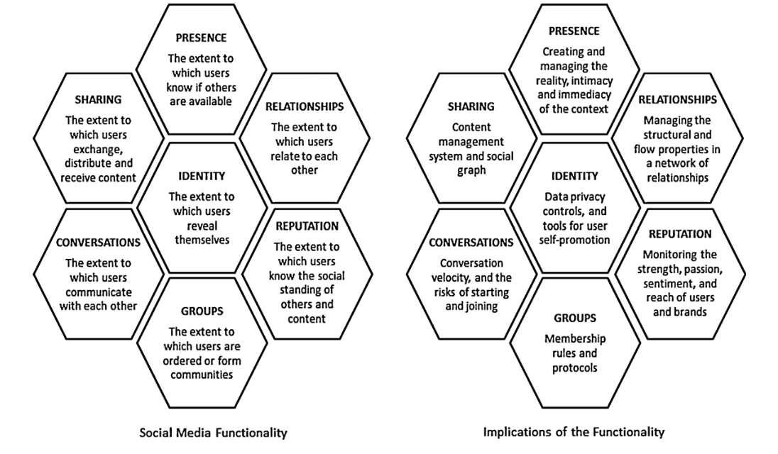

The honeycomb of social media

* Identity: The extent to which users reveal their identities in a social media setting. Identity includes disclosing information such as name, age, gender, profession, location, and portrays. Sometimes it also includes thoughts, feelings, likes and dislikes.
* Conversation: It represents the content that user communicate with others by using social media setting.
* Sharing: It represents the way how users exchange, distribute and receive content. Sharing often involves the exchange between people.
* Presence：Presence represents the extent to which users can know if other users are accessible. It includes knowing where others are, in the virtual world and/or in the real world, and whether they are available.
* Relationships: It represents the extent to which users can be related to other users. How users of a social media platform are connected often determines the what-and-how of information exchange.
* Reputation: Reputation is the extent to which users can identify the standing of others, including themselves, in a social media setting. In most cases, reputation is a matter of trust.
* Groups: This represents the extent to which users can form communities and subcommunities. The more ‘social’ a network becomes, the bigger the group of friends, followers, and contacts.

Based on the description above, it is useful for us to explore our own application by following these principles. As the features of our application is particular, which provoke us focusing on the Groups, Reputation, and conversation.

Reference: Kietzmann, J. H., Hermkens, K., McCarthy, I. P., & Silvestre, B. S. (2011). Social media? Get serious! Understanding the functional building blocks of social media. *Business Horizons*, *54*(3), 241–251. https://doi.org/10.1016/j.bushor.2011.01.005

# Concept(Yifan):

Generally, the concept of the project is a mobile application to improve the social connection between members and clubs. It allows members to know more about various clubs and societies and their holding events which helps them make decisions participating organization and events. As for organizers, it is designed to stimulate the effectiveness of operating their organizations and event planning. To achieve these goals, our team are decided to make a mobile app as the final form of our product. Due to the fact that it would need to inform users about all the surrounding events frequently and users would need to access all the information without location and time limitation, mobile phones would be the best device for our product. Additionally all the utility and functionalities can be included into an integrated mobile app easily. Thus, creating a mobile app would be the best form of our product. The aims of designing this mobile app are listed below:

Main features

The main features of the product should involve:

1. filtering available events to users;
2. presenting information about clubs and events;
3. allowing users to follow a club as a potential member, participating in an event as a casual member, or joining a club as a loyalty member;
4. rating the activeness of clubs and members for each joined clubs.
5. Rewarding system according to member's contribution and activeness
6. events pre-releasing system to collect feedbacks for organizers.
7. adding new friends by following and linking all friend info with Facebook.
8. Relation diagram function showing the connection with others based on previous activities and personal interests.

Highlights:

### Offer users an information publishment and sharing system by providing an integrated platform to help users to expand the way of knowing clubs events and increase the effectiveness of holding various events.

The core functionality will be novel integrated event information systems for both organizers and other students. For organizers, at the stage of planning of a future event, the platform will publish the general basic detail of it and collect feedbacks from other users for opinions. Then the organizers are able to use the data to change and adapt the event and activity. This can significantly prevent or solve the potential situations of holding an activity that no one interested to come or the event which can be a time and financial waste for the organization. As for students who are interested joining a club or event, this platform will exist as the official means of publishing related events information which provides related detailed information of related events according to the users preferences. Thus, the former situation that members can’t receive events’ notifications or receiving duplicate information from various media approaches will be solved.

### Providing an activeness evaluation system and corresponding rewarding system for all participants to stimulate members’ motivation.

Additionally, the product provides a new activeness evaluation system that will give different valuation on members in different clubs based on their contribution to the clubs such as attending an event and clubs activities arrangements etc… The valuation of activeness will be showed in form of levels. According to the “level” in certain club and student society, different image frame and unique badge will be given as system special identity rewards and the organizers can personalize their own rewards based on that as well. This will positively encourage all members in the clubs to participant and support related events and provide organizers a general view of member activities.

### Changing the traditional mode for studenting joining students’ clubs and organizations.

At last, after analysis of the data received from questionnaires, over ninety percent of the students receive clubs information from market day which leads to that fact that they will need to decide whether to join the club or not without attending any related events and activities. To change this traditional means of joining clubs. The system provides a unique way for users by simply choosing a preferred relation to the certain club. Currently, the user are allowed to choose relations as “Following” which will be marked as potential member, “Participating” as the causal member, “Joined” as the loyalty member of the club. Through this system, all users can join multiple clubs according to personal interests easily. At meantime the scale of each organization can be enlarged significantly.

## Target audience

General speaking, the audience of The UQ Club Hub is the current students of UQ in St Lucia campus. Since almost all the events and activities are held in campus, it is convenient for students to use the app to check the events agenda and participate immediately. Every students who is interested in any events or clubs held in campus is the audience of this application.

### personas用户画像————-2.png 用户画像——————3.png用户画像——1.png

### Expected outcome/s;

If our product were fully developed and being widely used by UQ students, the formal organization operating mode would be changed. Firstly, all users will be using our app as the priority approach receiving events information according to their customised interests filter. Also, UQ students are able to find out all the basic information about all the student clubs and societies including name, previous events, leadership, regulation and description of the organization etc... Users now have a simple way find out which clubs to join in by their preference without the limitation of time and location, and don’t have to worry missing the Market Day which is the major time for participating organizations. Additionally, the system are able to import the data of your friend list in the facebook, then users can see their friends name under certain event section. What’s more, users can make new friends that sharing the same interests and had participated same events by watching their personal profile and linking back to their facebook. The system itself provides a reward system to all users by giving special badges and levels according to the contributions they made to the club. Thus, the motivation of participating the club activities can be increased. As for organizers, by using this app, they are now able to publish a future event or activity and receive feedbacks from users. So they can make adjustment to the event which prevents potential commercial cost and increase the quality of the event itself. Also, they are able to present their organizations to the potential members by fulfilling the description and other essential information about the organization itself which save the time constructing redundant club website or booking places especially for propagating the club.

All in all, the application can not only simplify the process of participating clubs and arranging club events for all users but also enhance the connection between the organizations and club members which can significantly stimulate the overall UQ students organization development.

### Differences from existing products; (Current solutions; related projects) (also relate back to lectures)

Others (slack, etc.)

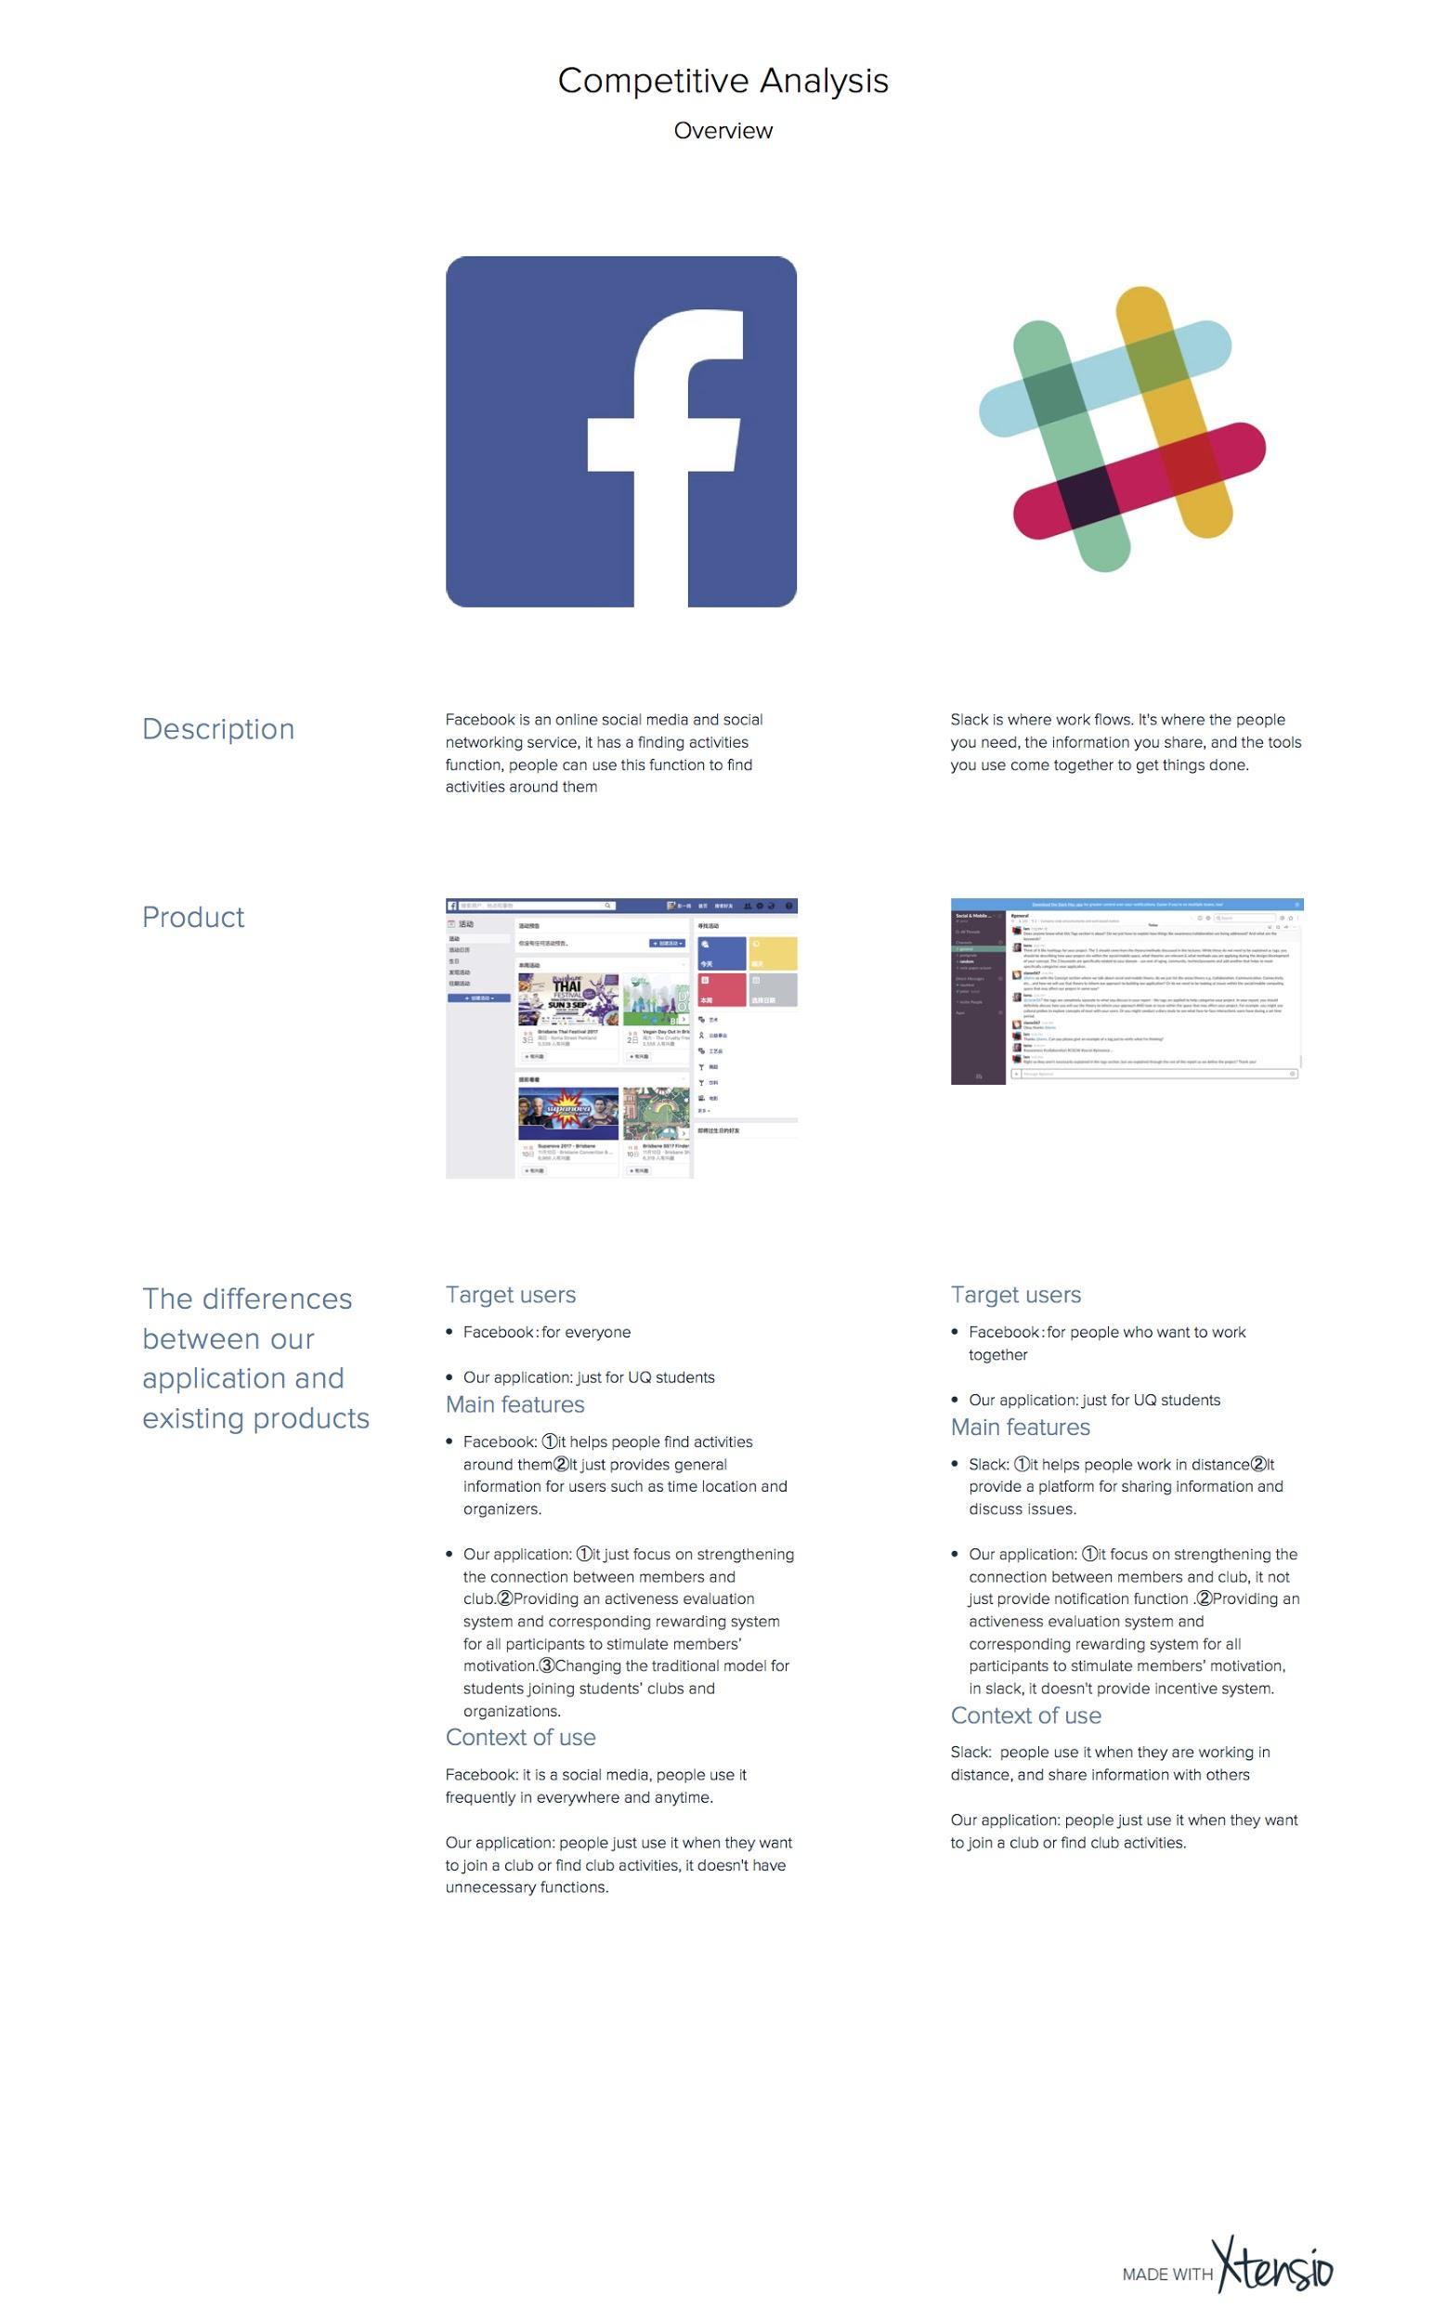

# Team (Danson):

## Members; (with course codes DECO3500/DECO7350)

Expertise;

Roles; (Responsibilities, including: leadership, management, equipments, meetings, transport)

Basic rules; (how to make decisions & how to deal with poor performance and conflicts)

Design approaches;

Development approaches;

**Introduction of the Team Members**

|  |  |  |  |  |  |
| --- | --- | --- | --- | --- | --- |
| **NAME** | **STUDENT NO.** | **COURSE CODE** | **MAJOR** | **ROLES** | **EXPERTISE** |
| Chunnan Zheng  (Nan) | 44097938 | DECO7350 | Master of Interaction Design | Team leader | He has previous studio experience and is good at the whole design process and team management. |
| Desheng Ban  (Danson) | 44017392 | DECO7350 | Master of Interaction Design | Designer | He is good at the front-end development and handcraft. |
| Yiming Peng  (Peter) | 44882143 | DECO7350 | Master of Interaction Design | Developer | He was an architect and good at graphic design. |
| Tianyi Zhang  (Tony) | 43986101 | DECO7350 | Master of Interaction Design | Designer | He is good at designing digital prototypes and organising user tests. |
| Yifan Lu  (Alvin) | 44106782 | DECO3500 | Bachelor of Information Technology | Organizer & Management | He has many software development experiences. |

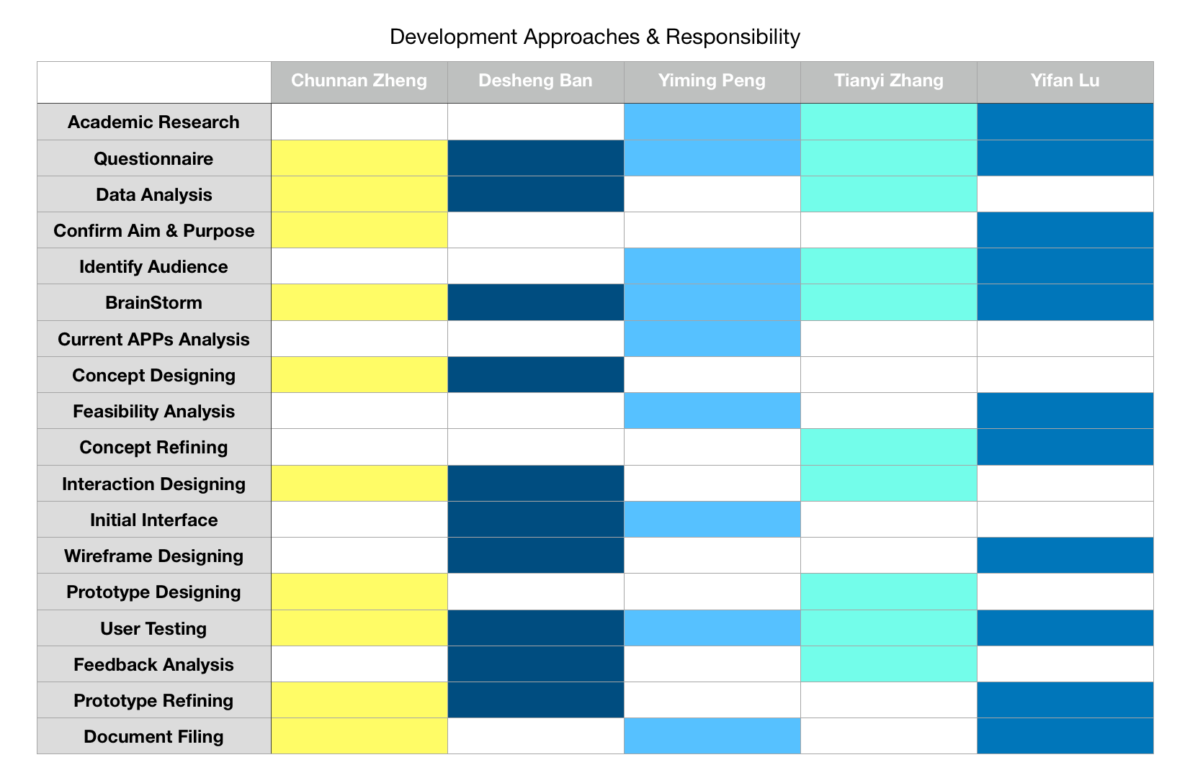

## Decision Making

Everyone has the right to make a decision. Generally, we use a fair method-vote to make a decision after several discussions. We have a regular meeting every week. Each member participants the meeting, discussion, data collection and analysis. During the meeting, we review the previous work and discuss new task. Everyone talk their idea and list it on the whiteboard. Then we choose the suitable one according to the project requirements. If there are two ideas meet the requirements at the same time, we will make a concept map to analyze them. Plus, we could ask the tutor or teacher to give us some suggestions.

## Poor performance handling & Conflicts Solving

We cannot ensure that everyone has equivalent workload. However, we will allocate task to each member fairly according to the responsibility table and project plan. If someone performing poorly or cannot finish the personal task on time, our group will talk with this member. If there is necessary, a warning will be given. If this situation happens more than three times, we will talk to the tutor or teacher. In case we cannot finish the project on time. During the meeting, each member needs to report the current work and the future plan. This is a kind of way to supervise group members with a positive attitude in the project progress.

We will try our best to avoid the conflicts. The regular meeting and decision making method provides a good way to express personal idea. If a conflict happens, we will give members enough time to clarify their thought. Group member will together analyze the reason and problem of the conflict. If a big conflict happens in our group, we will ask other groups to involve to coordinate. Otherwise, we will look for a help from the teacher and tutor. However, we will as far as possible avoid the conflict.

## ~~Design Approaches~~

~~Concept Design: In this stage, we did an online questionnaire by google form. The google form provides a total data analysis. It is easy to analysis and summary. After analyzing the data, we brainstorm the possible concept. Through a concept map and some criteria to choose the suitable concept.~~

~~Prototype Design: We will use the Balsamiq to design a wireframe. Then to do a basic interface test. After this, we will use the Sketch or In vision to design our prototype.~~

~~Iteration: The iteration includes concept iteration and prototype iteration. The concept iteration according to the concept criteria. These criteria come from the course requirement, academic research and the questionnaire response. The prototype iteration according to the user test and feedback. In the user test, the observation and interview method will be used to collect feedback.~~

~~Document: During the project progress, all the document and relevant data will be stored in the Google Drive and group GitHub. These data will help us have a clear idea of the project. It could help us to improve the design process and the final prototype.~~

**Design Approaches**

Empathy: In this stage, we use literature review, questionnaire, interview and discussion as initial research methods. Firstly, for the background research, we do academic research to find some related papers to support our concept. Then, we use a questionnaire and interviews to collect data and analyse it to identify the aims, purposes of the project and initial user requirements. The questionnaire mainly includes three kinds of groups: the organiser of a club or society, members of a club, students who never joined a club. These people provide different information for us to analyse. We discussed the idea with the teaching staff to get some feedback.

Design: In this stage, Questionnaire, brainstorming, related products analysis and academic research are used to support conceptual design.

Prototype: In this stage, Sketch, InVision and other design tools, such as PS and AI will be used to build prototypes for the concept. At first, we will use sketches the basic wireframes. The wireframes mainly include the layout of each screen, some pseudo content and the interaction flow. Based on the wireframes, we will test whether the target audience accepts the idea, what features work and what do not work. Later on, we will use Sketch and InVision (including Craft) to design a digital prototype with higher fidelity.

Iteration: The iteration process includes concept iteration and prototype iteration. The concept will be iterated according to the feedback we collect from representative users and the concept criteria. The criteria comes from the course requirements, usability requirements, and the expected outcomes of the project. The prototype iteration, as the name suggests, is changes made to prototypes according to the user test and the user’s feedback. In the user test, observation, questionnaire and interview methods will be used to collect feedback. We will also ask participants to think aloud when they interact with the prototype. The interview focuses more on user experience issues.

# Communication (Nan):

## Regular meeting sessions:

The team has a regular 2-hour meeting at the workshop on Tuesday afternoon. Since team members have signed onto different practical sessions, we plan to attend the second half of P01 and the first half of P02 on Wednesdays, which is another two hour. If needed, extra meeting or working time will be discussed according to the team members’ available time.

## Platforms for communication:

The team has set up a Github repository, a Slack channel, a Google Drive folder, and a Wechat group.

* The Github repository will be used to document the main content of the project, such as the interface design files and the team’s deliverables for the course. Github URL: <https://github.com/deco3500-2017/TeamBeyondBeingThere>
* The Google Drive folder is for documentation of the design process and file exchange. For example, the photos of brainstorming have been uploaded to the folder. Google Drive URL: <https://drive.google.com/drive/folders/0B3s2700t81vTZ0xiWjV1R1kzTGc?usp=sharing>
* Wechat is the most common instant messaging app which all team members regularly use. So we set up a group in the app and use the app as the main online communication tool.
* A slack channel has also been set up as a supplementary approach to collaboration. Slack channel: #deco3500-clubhub

## File management:

In the Google Drive folder and the Github repository, files should be clearly classified and stored in folders. All names of files and folders should be understandable, and no file should remain “untitled”. Spaces are allowed to be used in file names, if necessary.

Other rules involve: (1) Upper- and lower-cases should be properly used in file names; (2) Index number should be involved in brackets.

For example, photos of the brainstorming process should be named as “Brainstorming (1).jpg” to “Brainstorming (3).jpg”.

Nan is in charge of checking all file names on all platforms to keep them consistent.

## Milestones:

Milestones and main tasks to do before each milestone are listed below and also have been set up in our Github repository (<https://github.com/deco3500-2017/TeamBeyondBeingThere/milestones?direction=asc&sort=due_date&state=open>).

|  |  |  |  |  |
| --- | --- | --- | --- | --- |
| **Stage** | **Week** | **Tasks** | **Deliverables** | **Resources** |
| Empathise & Ideate | 5 | 1. Design and conduct an online questionnaire to collect the target user’s opinions on the problem.  2. Brainstorm to identify the problem space and ideate the initial idea.  3. Conduct academic research | 1. At least 50 responses to the questionnaire should be collected  2. Determined the form of the solution  3. A list of main features of the design  4. A list of findings of academic research | Access to prospective users |
| Ideate | 6 | 1. Gain feedback from peers in the workshop  2. Refine personas  3. Proposal writing | 1. A refined list of main features  2. Refined personas  3. Proposal |  |
| Design | 7 | 1. Turn conceptual design into concrete design  2. Design the interaction flow  3. Sketch the main screens  4. Determine the interface theme, including color scheme, font, etc. | 1. A diagram of the interaction flow  2. Sketches of the main screens  3. UI guidelines |  |
| Prototype & Evaluate | 8 | 1. Prototype in low fidelity  2. Invite users to test the initial concept with the prototype  3. Prepare for the report back in workshop | 1. A low-fidelity prototype  2. User test protocol, including a questionnaire  3. User test report (informal) | 1. Time, place to test  2. User test participants (n>5) |
| Iterate  (Design & Prototype) | 9  +  Mid-semester break | 1. Make changes based on the outcomes of the previous user test  2. Prototype in high fidelity | A high-fidelity prototype with interactivity | 1. Access to Sketch, InVision and Craft. |
| Evaluate | 10 | 1. Test the usability of the high-fidelity prototype  2. Prepare for the report back in workshop | 1. User test protocol, including a questionnaire  2. User test report (informal) | 1. Time, place to test  2. User test participants (n>5) |
| Iterate (Design & Prototype) | 11 | 1. Make changes based on the outcomes of the previous user test  2. Start to design a conference paper | Refined prototype |  |
| Finalise | 12 | 1. Finish all remaining tasks  2. Prepare for the report back in workshop  3. Prepare promotional materials for the final demonstration, such as flyers, lollies, etc. | 1. Conference poster  2. Other promotional materials  3. Final prototype | Budget for the promotional materials |
| Demonstrate | 13 | Demonstrate the final prototype |  |  |

# Changes made based on feedback from pitch

1. Focus on the member’s relationship with clubs, instead of members’ connections to one another.

Based on the feedback from the teaching staff, we can see the main focus of our concept was not clearly conveyed. In our pitch, we wanted to use the concept to improve the member’s relationships with both the club and other members. This was because one of the reasons why students wanted to join a club was to meet friends. Therefore, although the main focus of our concept was to enhance the social connection between the member and the club, we added some features to empower members to connect one another. However, it made the main focus ambiguous. The audience of our pitch were more curious about the supplementary features than the main features. So after receiving the feedback, we removed the feature which supported communication among members to emphasize the main feature.

1. Differences with facebook. (1) what do we focus on, what facebook focus on (2) what clubs or members cannot achieve by facebook (3) what we should do to reduce the concern of too many platforms

Some features of our concept were similar to, but different from, Facebook Page and events. We added a section in the proposal to compare our concept to Facebook. Please refer to Competitor analysis.

Tags:

Asynchronous Distributed Interaction; Awareness; Mobile/Social; Social Software; Identity; community; mobile app!

Proofread & Use Grammarly to fix problems

Markdown formatting

References:

Xtension